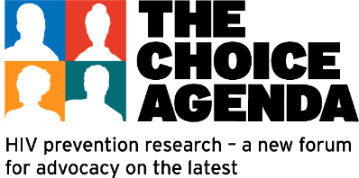
Resources
The Quest For An HIV Cure - Will It Be Discovered in Africa?
Thursday, December 11, 2025
The Choice Agenda
https://avac.org/project/choice-agenda/
TCA webinar materials
https://tinyurl.com/tcawebinarmaterials
24 Hours to Save AIDS Research
https://saveaidsresearch.org/
Recent paper from Dr. Ndung’u’s group “HIV cure research contributions from Africa in the last three decades” in case it might be a helpful resource:
https://pmc.ncbi.nlm.nih.gov/articles/PMC12370771/

Link for the demographics resource, (due for an update):
https://www.treatmentactiongroup.org/cure/resource-on-the-demographics-of-participation-in-hiv-cure-related-clinical-research/

This paper describes the stakeholder consultations that were involved in conducting what I think was the first HIV cure-related clinical trial to include an ATI on the African continent
https://pmc.ncbi.nlm.nih.gov/articles/PMC12134397/

The WHO updated guidelines on HIV discosure for children and adolescents
https://www.who.int/news/item/15-07-2025-new-who-guidance-on-hiv-disclosure-for-children-and-adolescents

The Sub-Saharan African Network for TB/HIV Research Excellence (SANTHE website)
https://www.santheafrica.org/

